**VIRTUAL LEARNING REVIEWS**

**ADMIN PROFILE**

**1.Edit School option is missing**

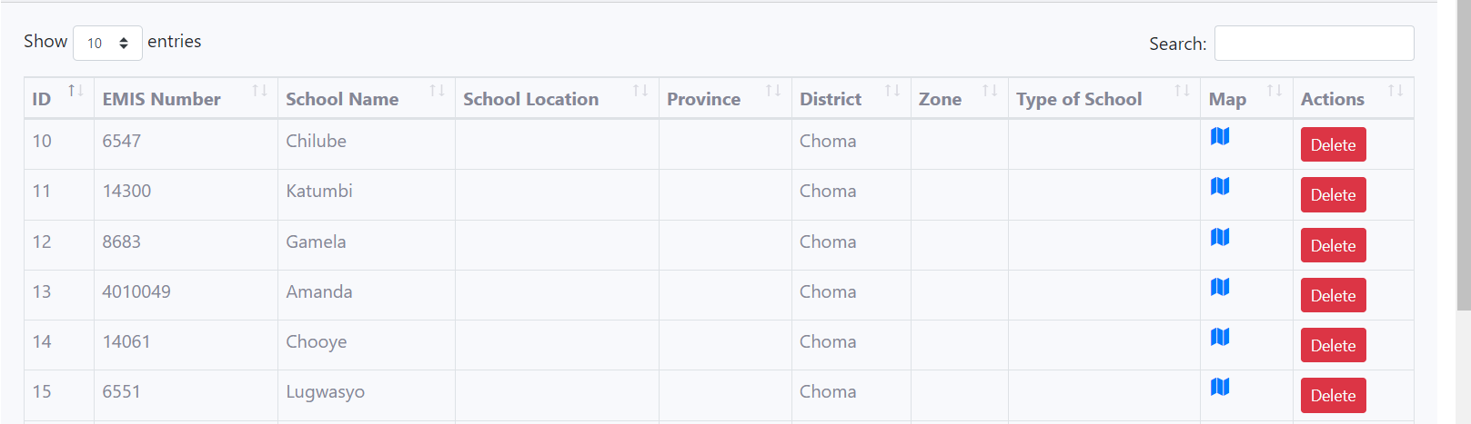

**DRC PROFILE**

**1.Zone communication not yet implemented**

**2.Lets move add zones to debs account**

**3.when I try to edit debs profile (submit button)**

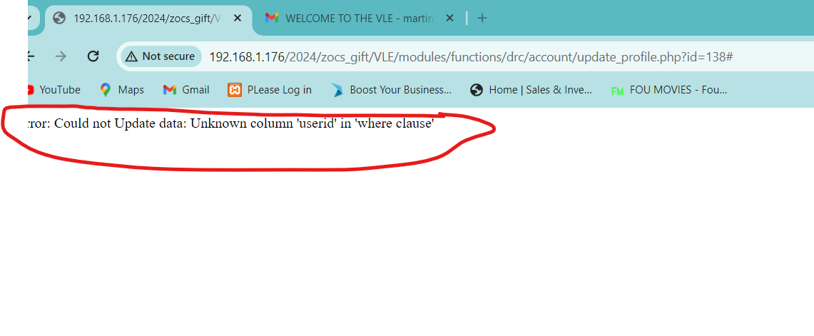

**4.Change report to enrollment**

**5.** **Should debs be able to see all teachers even if they were not created by him or her or it’s an error?**

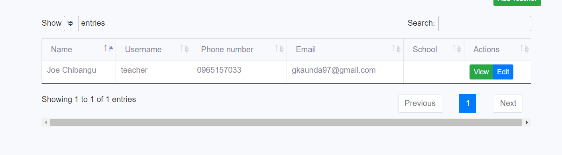

**5.Lets update the database : when adding a school**

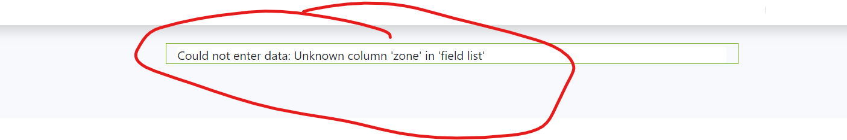

**6.On edit teacher there is no select school**

**TEACHER**

**1.QUERY:Teacher shoudnt see queries raised by other teachers**

**b.Teacher shouldn’t close the query**

**c.Shouldnt reply to queries**

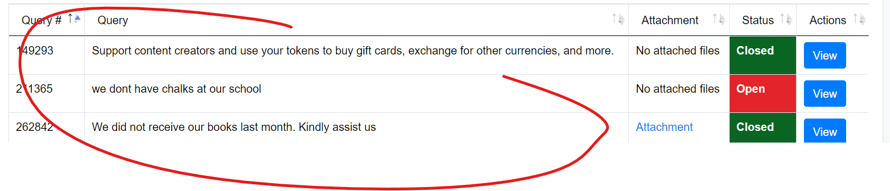

**2.when Adding learning materials let there be a book cover and book grade**

**3**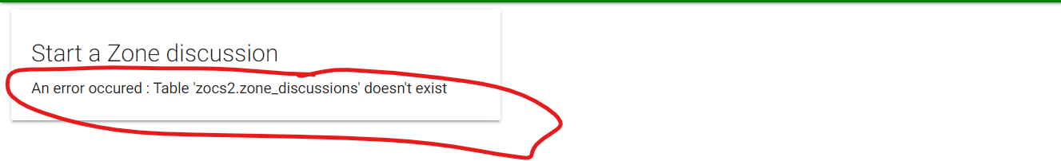

**4.Teacher to have access to learning materials which were posted by the fellow teachers**

**5.where do the teacher make announcemet to parents? If its not necessary lets remove it from parents profile.**

**PARENTS**

**1.Leaerning Materials: they shouldn’t be restrictions on materials.(all parents to have access to all materials for all grades or age.**

